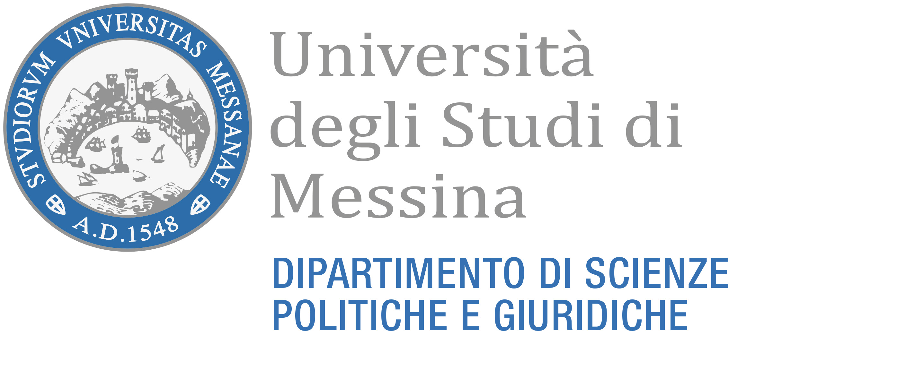

CALENDARIO DELLE LEZIONI - ANNO ACCADEMICO 2022-23

Classe L-36 SCIENZE POLITICHE E DELLE RELAZIONI INTERNAZIONALI

Political Sciences and International Relations
First Year (65CFU)
INSEGNAMENTI | CFU | DOCENTI | SEMESTRE | GIORNO | ORA | AULA | Inizio Lezioni | LINK
SPS/07 – SPS/09 SOCIOLOGY OF GLOBALIZATION | 10 | L. LO SCHIAVO  M. MUSOLINO | 1°  2° | THU-FRI | 14.30-16.30 | V. TOMEO | 28/10 | TEAMS
SECS-P/01 PRINCIPLES OF ECONOMICS | 8 |  | 1°
M-STO/02 EARLY MODERN HISTORY | 8 | S. BOTTARI | 1° | MON-TUE-WED | 14.30-16.30 | L. CAMPAGNA | 03/10 | TEAMS
IUS/09 PUBBLIC LAW | 8 | A. MORELLI | 1° | MON-TUE-WED | 9.00-11.00 | L. CAMPAGNA | 03/10 | TEAMS
IUS/01 ANTI-CORRUPTION PRIVATE LAW | 8 |  | 2°
Supplementary Teaching: 3 examschosen by the student
INSEGNAMENTI | CFU | DOCENTI | SEMESTRE | GIORNO | ORA | AULA | Inizio Lezioni | LINK
IUS/10 GLOBAL ADMINISTRATIVE LAW | 8 | A. LUPO | 1° | THU-FRI | 11.00-13.00 | AULARIO  N. 102 | 06/10 | TEAMS
SPS/03 HISTORY OF EUROPEAN POLITICAL INSTITUTIONS | 8 | C. TRIMARCHI | 1° | THU-FRI | 9.00-11.00 | AULARIO  N. 102 | 06/10 | TEAMS
IUS/13 INTERNATIONAL ORGANIZATION | 8 |  | 1° |  |  |  |  | TEAMS
L-LIN/04 FOREIGN LANGUAGE (FRENCH) | 8 | S. PIRARO | 2°
L-LIN/14 FOREIGN LANGUAGE (GERMAN) | 8 |  | 2°
L-LIN/07 FOREIGN LANGUAGE (SPANISH) | 8 |  | 2°
IUS/12 TAX LAW | 8 | P. ACCORDINO | 2°
SPS/13 HISTORY AND ISTITUTIONS OF AFRICA | 8 |  | 2°

Second Year
INSEGNAMENTI | CFU | DOCENTI | SEMESTRE | GIORNO | ORA | AULA | Inizio Lezioni | LINK
IUS/13 INTERNATIONAL LAW AND HUMAN RIGHTS | 8 |  | 1°
SECS-P/02 INTERNATIONAL ECONOMICS | 8 | E. MILLEMACI | 1° | MON-TUE-WED | 14.30-16.30 | AULARIO  N. 104 | 03/10 | TEAMS
M-STO/04 CONTEMPORARY HISTORY | 8 | M. ATERRANO | 2°
SPS/02 HISTORY OF POLITICAL THOUGHT | 8 |  | 2°
SPS/01 POLITICAL THEORY  POLITICAL THEORY (Mod A) (5 CFU)  POLITICAL THEORY (Mod.B) (5 CFU) | 10 |  | 1°  2°

Supplementary Teaching: 3 examschosen by the student
INSEGNAMENTI | CFU | DOCENTI | SEMESTRE | GIORNO | ORA | AULA | Inizio Lezioni | LINK
L-LIN/04 FOREIGN LANGUAGE (FRENCH) (Condiviso percorso 100) | 8 | S. PIRARO | 2°
L-LIN/14 FOREIGN LANGUAGE (GERMAN) | 8 |  | 2°
L-LIN/07 FOREIGN LANGUAGE (SPANISH) | 8 |  | 2°
IUS/10 GLOBAL ADMINISTRATIVE LAW | 8 | A. LUPO | 1° | THU-FRI | 11.00-13.00 | AULARIO  N. 102 | 06/10 | TEAMS
SPS/03 HISTORY OF EUROPEAN POLITICAL INSTITUTIONS | 8 | C. TRIMARCHI | 1° | THU-FRI | 9.00-11.00 | AULARIO  N. 102 | 06/10 | TEAMS
IUS/13 INTERNATIONAL ORGANIZATION | 8 |  | 1°
IUS/12 TAX LAW | 8 | P. ACCORDINO | 2°

Third Year
INSEGNAMENTI | CFU | DOCENTI | SEMESTRE | GIORNO | ORA | AULA | Inizio Lezioni | LINK
IUS/02 COMPARATIVE LEGAL SYSTEMS | 8 | A. CUCINOTTA | 1° | MON-TUE-WED | 09.00-11.00 | AULARIO  N. 104 | 03/10 | TEAMS
IUS/14 EUROPEAN UNION LAW | 8 | M. MESSINA | 1° | MON-TUE-WED | 16.30-18.30 | AULARIO  N. 104 | 03/10 | TEAMS
SPS/06 HISTORY OF INTERNATIONAL RELATIONS | 8 | A. VILLANI | 1° | MON-TUE-WED | 11.00-13.00 | AULARIO  N. 104 | 03/10 | TEAMS
SEPS/04 POLITICAL SCIENCE AND INTERNATIONAL RELATION | 8 | E. CUSUMANO | 2°
L-LIN/04 FOREGN LANGUAGE (FRENCH) (Condiviso percorso 100) | 8 | S. PIRARO | 2°
LIN/14 FOREGN LANGUAGE (GERMAN) | 8 |  | 2°

Supplementary Teaching: 3 examschosen by the student
INSEGNAMENTI | CFU | DOCENTI | SEMESTRE | GIORNO | ORA | AULA | Inizio Lezioni | LINK
IUS/10 GLOBAL ADMINISTRATIVE LAW | 8 | A. LUPO | 1° | THU-FRI | 11.00-13.00 | AULARIO  N. 102 | 06/10 | TEAMS
SPS/03 HISTORY OF EUROPEAN POLITICAL INSTITUTIONS | 8 | C. TRIMARCHI | 1° | THU-FRI | 9.00-11.00 | AULARIO  N. 102 | 06/10 | TEAMS
IUS/13 INTERNATIONAL ORGANIZATION | 8 |  | 1°
L-LIN/04 FOREIGN LANGUAGE (FRENCH) | 8 | S. PIRARO | 2°
L-LIN/14 FOREIGN LANGUAGE (GERMAN) | 8 |  | 2°
L-LIN/07 FOREIGN LANGUAGE (SPANISH) | 8 |  | 2°
IUS/12 TAX LAW | 8 | P. ACCORDINO | 2°
SPS/13 HISTORY AND ISTITUTIONS OF AFRICA | 8 |  | 2°

